**PROGRAM 6**

**Aim**

To write a Python program to simulate the **Vacuum Cleaner problem**, where a vacuum agent cleans all dirty locations in an environment using a simple reflex or search-based strategy.

**Algorithm**

1. Start the program and define the environment (rooms/locations as A, B, etc.).
2. Assign each location a state: **Clean** or **Dirty**.
3. Place the vacuum cleaner at a starting location.
4. Check the current location:
   * If **Dirty**, clean it (change status to Clean).
   * If **Clean**, move to the next location.
5. Continue the process until **all locations are Clean**.
6. Display the sequence of actions taken by the vacuum cleaner and the final state of the environment.

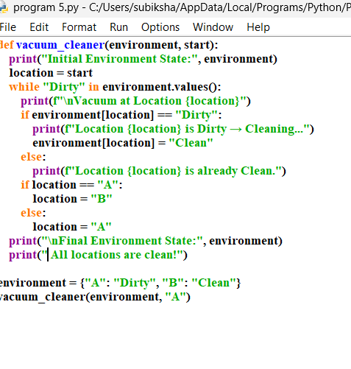

OUTPUT:

